How to get started with Päikky
Your early childhood education provider is using the Päikky system, which lets you mark your child’s care needs and handle communication with your kindergarten electronically.
This is a guide to help you get started with the service. Welcome to the Päikky family!
How do I access Päikky?
You can use Päikky Guardian on a computer, smart phone or tablet. The Päikky Guardian web app works with the most common browsers. Fully supported browsers are: Google Chrome, Mozilla Firefox and Safari. The Päikky Guardian mobile app works with Android and iOS phones. It can be downloaded from the Play Store (Android) and the App Store (iOS).
Using internet browser you can access Päikky at https://vora.paikky.fi
After starting Päikky guardian mobile application select “Vöyri” as your service provider.

First login to Päikky – Activating username
Your early childhood education provider has created for you, as guardian of your child, a username based on your mobile phone number. You must activate this username by identifying yourself using “strong” methods (online banking credentials or mobile certificate) and setting a password. Each guardian should have their own username. Guardians cannot see each other’s contact details, but all information about a child is visible to all his/her guardians.
During strong identification your personal ID number from the national information registry is compared to your ID in the Päikky system. If the system has a guardian with that ID, the username is activated. After identification is completed, you are returned to Päikky Guardian to set a password.
Your password must meet your provider’s requirements, which may vary depending on your provider. A good password typically has at least 8 characters and contains at least two letters, one number and one special character (. , : ; > * - + = ! ? @ $ & ( ) /). Your password will usually be valid for 180 days, but this may also vary by provider.
On Päikky’s login screen
- Choose Activate username.
- Choose Identify yourself.
- Follow instructions in identification screens.
- Write the password of your choice in the proper spaces.
- Choose Set password.
2
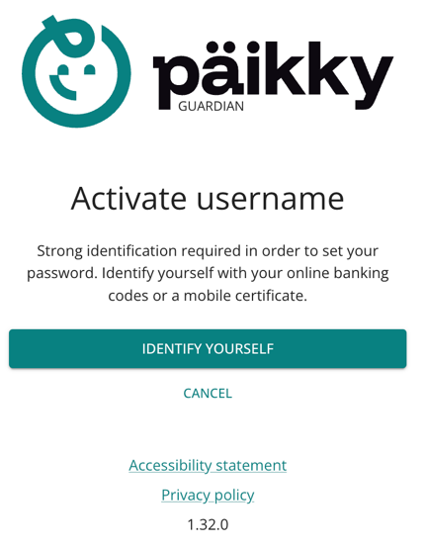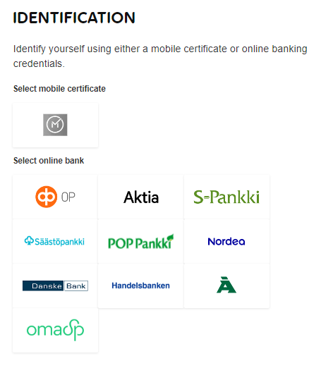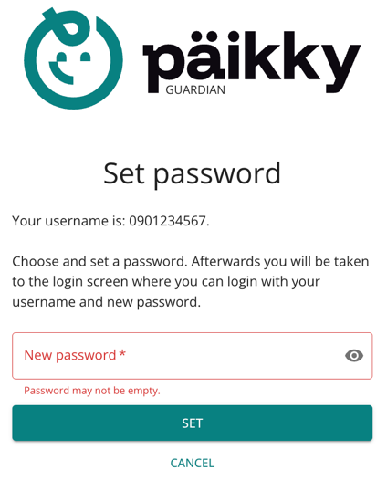

If the system does not find a guardian with the ID returned during identification, the username will not be activated. In this case Päikky Guardian will ask you to contact your provider to check that your information in the system is correct.

Without finnish personal identity code
It is not possible for a person who does not have a Finnish personal identity code to identify themselves strongly electronically in Finland.
In this case, the identification of the person is carried out by the staff of the daycare centre. In the Päikky Daycare Centre application, a person is marked as identified. After this, the person can activate their username through the email they receive.
The email-based method can also be used to reset a person's password if they forget it.

Instructions for using Päikky
More detailed instructions on how to use Päikky can be found after logging in under the 'Profile' tab. Here's a quick overview of the most important things to get started.

Calendar and making plans

On the calendar tab, you make plans for your children, report absences and can monitor the time they spend in early childhood education. The first task is to plan the attendance and absences for the coming weeks, these are called plans. Reservations must be made weekly by the day and time of the week specified by your service provider. After this, the calendar will be locked and reservations can no longer be made. You'll be reminded of unmade plans. The reminder will always be sent on the same day of the week each week determined by your service provider.

The plan can be made in 5-minute increments.

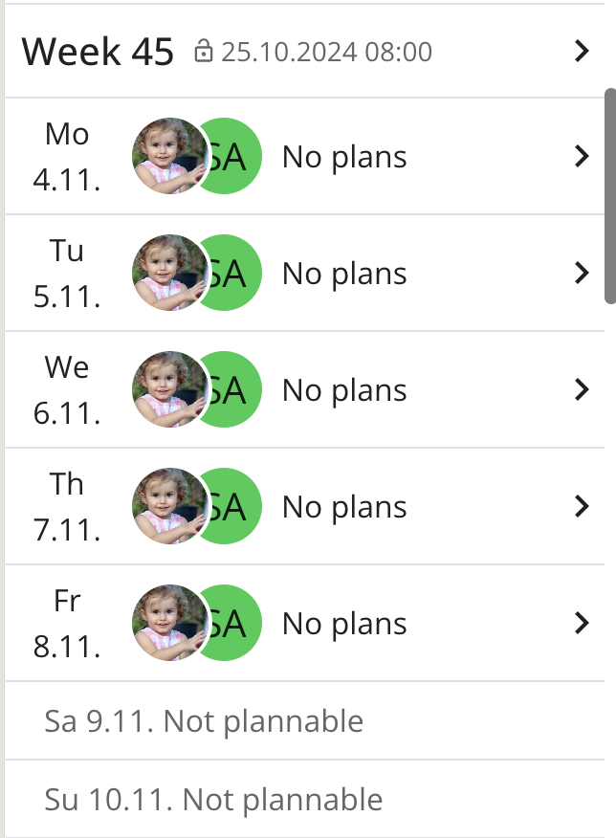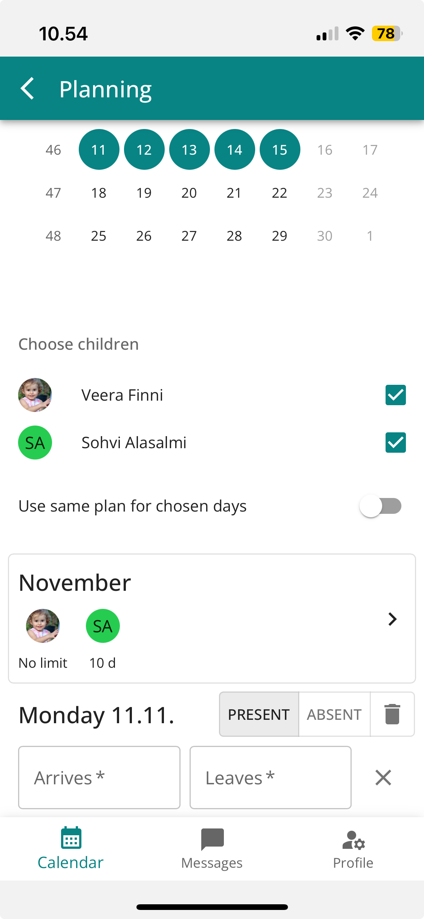

There is no need to divide the preschool time separately, Päikky automatically divides the plan into free preschool education and paid early childhood education time. Preschool education time must not be deducted.

The calendar shows when the plan for that day must be made at the latest before it locks. Changes can be made up to the date the plan is locked.

Planning
- Log in to Päikky
- Select Calendar.
- In the calendar, select the week (by selecting the week heading) or the day for which you want to make a plan.
- Check that the children you want to make a plan for are selected
- Choose a plan that's right for each day, or use the same plan for all days.
- Save the plan.
If you have more than one child in your care, you can save the same plans for them.

If the plans repeat the same weekly, save a default plan for your child using the "Default plans" functionality in the calendar. When a default plan is made for a child, reservations are made automatically according to the default plan. Any changes to the default plans must always be made in the planning before the calendar locks up.

You can make a wide variety of plans in the Päikky calendar. Below are some common examples of how you can use the Päikky calendar.

Regular plans
When children have regular plans that repeat the same week after week, it's a good idea to use default plans. The default plans can also be used if some days of the week are always the same.
For example, a child always has Thursday and Friday off, so a "Planned absence" is made in the default plan for these days. Every week, Monday, Tuesday and Wednesday of the child are planned separately.

Planning on alternate weeks

If you want to plan several weeks for your child at once, you can select them from the planning view at once and plan them. In this case, it is advisable to start planning by selecting "Planning" from the menu in the calendar view.
And choose the desired weeks to plan. Weeks 37 and 39 selected in the picture.
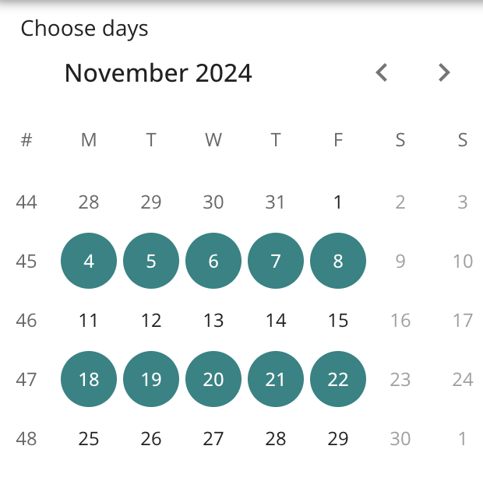

Planning for regular shifts

When planning is to correspond to three-week shifts, for example, morning shifts can be planned at once by selecting morning shifts from the calendar and making plans for them.
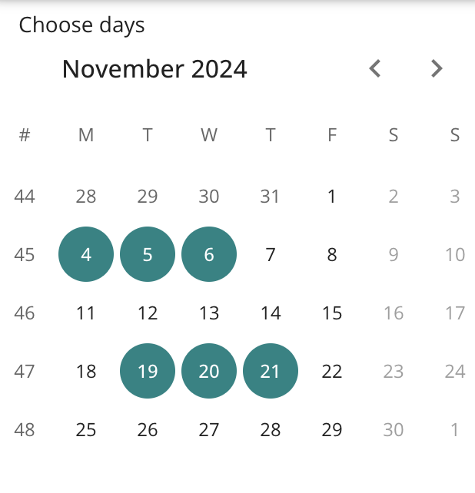
Next, evening shifts for the period etc. can also be planned.

Longer absences

If the child is absent for a longer period, it can be easily reported from the calendar by selecting the time period, children and absence. In this case, the option "Use the same plan for selected days" is also used. Days can be selected for several months, so you can report an absence that lasts the whole summer at once, for example.
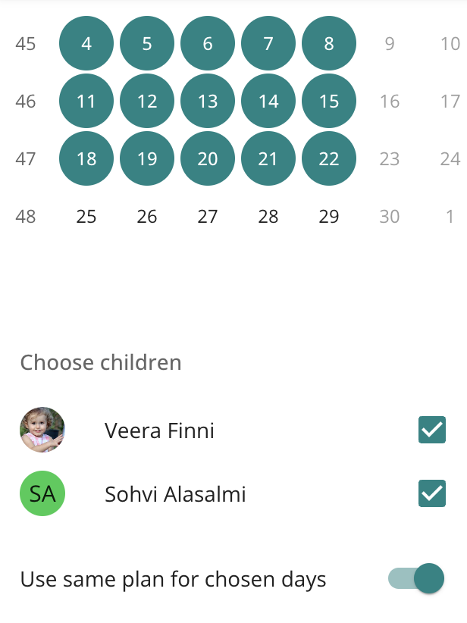

Plan change when day is already locked
Changes to a locked plan are made by selecting that day in the calendar and filling in the plan change. A child can be reported abruptly absent or ill.
A message about the notification will also be sent to the daycare centre, where you can enter additional information.
Once the plan has been blocked, days planned to be absent cannot be changed to attendance days through the Päikky Guardian application, but the matter must be agreed upon with the daycare centre or family daycare provider.

Communications in Päikky
Päikky offers an easy communication opportunity between the daycare centre and the guardian. In the Messages section, you can see all your child's messages, announcements, and surveys at once. The message may be about your child, or it may be sent to all the children in the group, or even to all the children in the kindergarten. You can also send a message yourself about your own child to the daycare centre.
Tap on the message to read the message and view any attached images. You can also reply to a message. You can only reply to messages directed at your own child, not messages from a group or kindergarten.
On the 'Profile' tab, under "Notifications", specify how you will receive notifications of incoming messages and reminders of missing plans.
. 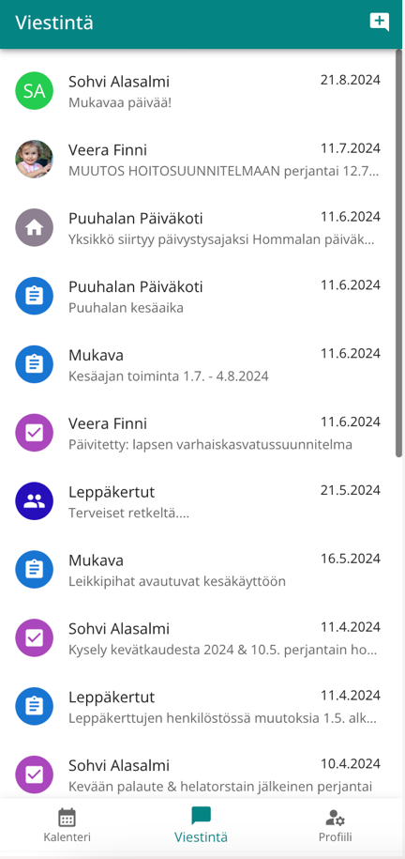

Profile
In your profile, you'll find information and settings about yourself and your children. For example, the notification settings mentioned above, but you can also, for example, save as substitute applicants persons who can pick up children from early childhood education.

Forgot password!
If you've forgotten your password, tap Forgot password? text on the Päikky login page. After that, you need to use strong identification, after which you can set a new password. If you do not have a Finnish personal identity code, you must contact your service provider.

